
Identify Your Top Three Areas of Expertise
Use this worksheet to identify your top three areas of expertise and create compelling messages for various platforms. This will help you craft effective content for social media, email, web, and media pitches. This framework is designed to tell a concise story and drive action.
Step 1: Select Your Top Three Topics
- Topic 1: ___________________________
- Topic 2: ___________________________
- Topic 3: ___________________________
Step 2: Build Your Messages
Topic 1: __________________________
- Awareness: A statistic, trend, common problem, or pain point.
  - Example:
    - Introverted entrepreneurs need to be visible to grow their businesses, and 96% of B2B buyers want to see more content from industry leaders.
  - Your turn!
    - ____________________________________________________________________________________________________________________________________________________________________________________________________________________________________________________________________________________________
- Credibility: Simplified, high-level narrative illustrating success.
  - Example:
    - I help them find ways to strategically execute PR in ways that feel comfortable and authentic.
  - Your turn!
    - ____________________________________________________________________________________________________________________________________________________________________________________________________________________________________________________________________________________________
- Together: Encourage the audience to take the next step with you.
  - Example:
    - We work together to hone messaging and develop repeatable methods of outreach and amplification.
  - Your turn!
    - ____________________________________________________________________________________________________________________________________________________________________________________________________________________________________________________________________________________________
Topic 2: _______________________________
- Awareness:

- Credibility:

- Together:

Topic 3: _______________________________
- Awareness:

- Credibility:

- Together:

Visual processor? Prefer to doodle and ponder? The matrix below is my favorite way to think through message building, using the ACT framework.
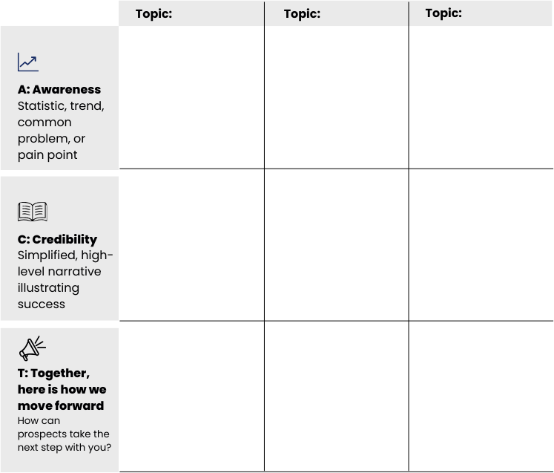

Get Personalized Feedback
Email your message drafts to:
Alexson Calahan
alexson@SmallAdventuresCommunications.com
www.SmallAdventuresCommunications.com

